**The SOBHA ACADEMY**

**PANNIYANKARA**

**2024 - 25ENGLISH PROJECT FILE**

**ARTIFICIAL INTELLIGENCE**



**SUBMITTED BY :**

**JITH P**

**XII**

**INDEX**

# **INTRODUCTION TO AI**

# **IMPORTANCE OF AI**

# **HISTORY OF AI**

# **APPLICATIONS OF AI**

# **AI : BOON OR BANE**

# **FUTURE OF AI TECHNOLOGY**

# **TECHNOLOGIES BASED ON AI**

# **CONCLUSION**

# **BIBLIOGRAPHY**



## **INTRODUCTION TO AI**

Artificial Intelligence (AI) is a branch of computer science that focuses on creating machines and systems that can perform tasks that typically require human intelligence. These tasks can include problem-solving, understanding language, recognizing patterns, and learning from experience. AI systems can be designed to perform a wide range of functions, from simple tasks like playing chess or recommending products online, to more complex activities such as autonomous driving, medical diagnosis, and NLP.

One of the key components of AI is machine learning, a subset that focus on enabling computers to learn from data without being explicitly programmed. Machine learning algorithms analyse vast amounts of data toidentify patterns and make predictions or decisions based on the information gathered. This technology is widely used in applications like recommendation systems, image and speech recognition, and predictive analytics.

Another crucial aspect of AI is natural language processing (NLP), which enables computers to understand, interpret, and generate human language. ****NLP powers virtual assistants like Siri and Alexa, Chabot’s, language translation services, and sentiment analysis tools. By processing and generating language, AI systems can interact with users more effectively and provide valuable insights from textual data.

In conclusion ,AI represents a ground breaking technological frontier with thepotential to revolutionize industries and improve human lives.

## 

## **IMPORTANCE OF AI**

Artificial Intelligence (AI) is becoming increasingly important in various fieldsdue to its ability to automate processes, analyse large amounts of data, andmake predictions or decisions based on that data. Some key reasons why AIis important include:

**Automation:** AI can automate repetitive tasks, freeing up human workers to focus on more complex and creative work.

**Data Analysis:** AI can analyse large volumes of data much faster and moreaccurately than humans, leading to insights and patterns that can inform decision-making.

**Personalization:** AI can be used to personalize experiences for users, suchas in marketing, healthcare, or entertainment, leading to improved customersatisfaction and engagement.

**Predictive Capabilities:** AI can predict outcomes based on historical data, enabling businesses to make informed decisions and anticipate future trends.

**Efficiency:** AI can streamline operations and optimize processes, leading to cost savings and improved productivity.****

**Innovation:** AI has the potential to drive innovation in various industries, leading to the development of new products, services, and business models.

Overall, AI is important because it has the potential to transform how businesses operate, how people interact with technology, and how various industries approach problem-solving and decision-making.



## **HISTORY OF AI**

The history of AI can be traced back to ancient times when philosophers andinventors envisioned creating artificial beings with human-like capabilities. However, the modern era of AI began in the 1950s with the pioneering work of researchers such as Alan Turing, who proposed the concept of a machinethat could exhibit intelligent behaviour indistinguishable from that of a human.

In 1956, the term "artificial intelligence" was coined during a conference atDartmouth College, where researchers from various disciplines came together to explore the possibilities of creating machines capable of intelligent behaviour. This event marked the birth of AI as a field of study.

Over the decades, AI has experienced periods of significant advancementand setbacks, known as "AI winters," where interest and funding for AI research fluctuated. However, recent years have seen a resurgence in AIdevelopment, driven by advancements in computational power, big data, machine learning algorithms, and deep learning techniques.

****Today, AI technologies are increasingly integrated into various aspects of our lives, from virtual assistants and recommendation systems to autonomous vehicles and medical diagnostics. The ongoing research and development in AI continue to push the boundaries of what machines can achieve, raising important ethical and societal questions about the impact ofAI on individuals and society as a whole.



****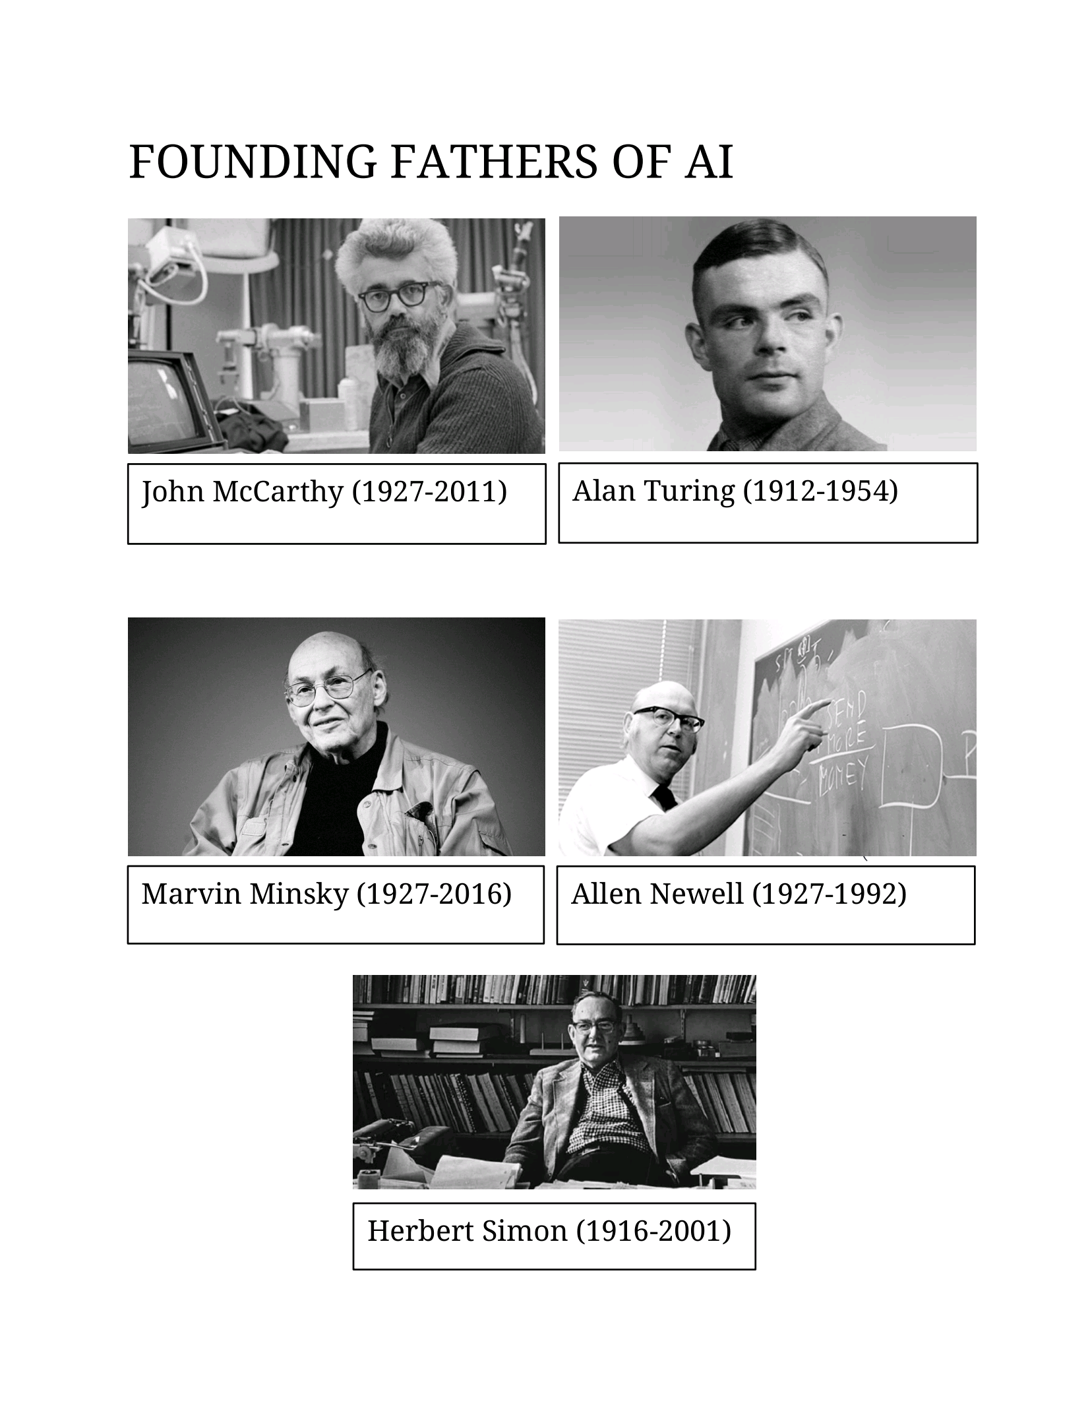

## **APPLICATIONS OF AI**

AI has the potential to make a significant impact in various social fields byaddressing complex challenges and improving the quality of life for individuals and communities. Some common applications of AI in social fields include :

**Healthcare:** AI is used in healthcare for early disease detection, personalized treatment plans, medical image analysis, drug discovery, patient monitoring, and telemedicine. AI-powered systems can help healthcare professionals make more accurate diagnoses and improvepatient outcomes.

**Education:** AI can personalize learning experiences for students by adapting to their individual needs and learning styles. AI-powered tools canprovide personalized tutoring, automate administrative tasks for educators, and offer interactive learning platforms to enhance student engagement.

**Public Safety:** AI is used in public safety for predictive policing, emergencyresponse optimization, video surveillance analysis, and disaster management. AI-powered systems can help law enforcement agencies ****respond more effectively to emergencies and prevent crimes.

**Social Media Analysis**: AI is used to analyse social media data for sentiment analysis, trend detection, fake news detection, and social networkanalysis. AI-powered tools can help researchers, policymakers, and organizations understand public opinion, detect misinformation, and identifyemerging social trends.

**Agriculture :** AI is monitoring crops, predicting yield, and optimizing irrigation in agriculture, raising debates about the impact on traditionalfarming practices and employment.

**Cybersecurity:** AI can enhance cybersecurity measures by detectingpotential cyber threats, identifying vulnerabilities in the network, and responding to security incidents in real-time. AI-powered cybersecuritysolutions can help banks protect sensitive customer data, prevent databreaches, and safeguard their digital infrastructure.

**Wildlife :** AI in wildlife conservation aids in species monitoring, poaching detection, habitat protection, and data analysis. It enables real-time trackingof animals, identification of endangered species, and predictive modelling forconservation efforts. AI technologies like ****drones, camera traps, and machinelearning algorithms play a crucial role in safeguarding biodiversity and preserving ecosystems.

**Space :** AI is aiding in space navigation, mission planning, and thedetection of new astronomical phenomena in space exploration.

**Transportation**: AI is used for autonomous vehicles, traffic prediction, androute optimization.

**Manufacturing:** AI helps in quality control, predictive maintenance, andproduction optimization.

## 

## 

## **AI : BOON OR BANE**

### **BOON**

**Increased efficiency and productivity**: AI can automate tasks, analyse dataquickly, and make decisions faster than humans, leading to improved efficiency and productivity in various industries.

**Enhanced decision-making**: AI algorithms can process vast amounts of data to provide insights and recommendations, helping individuals and organizations make better decisions.

**Innovation and technological advancements**: AI has the potential to drive innovation and spur advancements in fields such as healthcare, transportation, finance, and more, enabling new capabilities and solutions.

**Personalized experiences**: AI-powered systems can analyse user data to deliver personalized recommendations, services, and experiences tailored toindividual preferences.

**Improved safety and security**: AI technologies can enhance safety and security measures by

****detecting anomalies, predicting risks, and preventing potential threats in areas like cybersecurity, public safety, and disaster response.

### **BANE**

**Job displacement**: The automation of tasks through AI technologies canlead to job displacement, as certain roles become obsolete or are replacedby AI-powered systems, potentially causing unemployment and economicdisruption.

**Bias and discrimination**: AI algorithms can perpetuate biases present in the training data, leading to unfair or discriminatory outcomes in areas suchas hiring practices, criminal justice decisions, and loan approvals.

**Privacy concerns**: The use of AI relies on vast amounts of data, raisingconcerns about data privacy and security, including unauthorized access, data breaches, and misuse of personal information.

**Dependence on technology**: Overreliance on AI systems can lead to a lossof critical skills or knowledge among individuals, as well as vulnerabilities inessential systems if AI malfunctions or is compromised.****

**Ethical dilemmas**: The development and deployment of AI raise complex ethical dilemmas related to accountability, transparency, bias mitigation, andthe impact on society, requiring careful consideration and regulation to address these challenges effectively.



## **FUTURE OF AI TECHNOLOGY**

**Reinforcement Learning**: Reinforcement Learning is an interesting field ofArtificial Intelligence that focuses on training agents to make intelligent decisions by interacting with their environment.

**Explainable AI**: this AI techniques focus on providing insights into how AImodels arrive at their conclusions.

**Generative AI**: Through this technique AI models can learn the underlyingpatterns and create realistic and novel outputs.

**Edge AI**: This AI involves running AI algorithms directly on edge devices, such as smartphones, IoT devices, and autonomous vehicles, rather than relyingon cloud-based processing.

**Quantum AI**: Quantum AI combines the power of quantum computing with AI algorithms to tackle complex problems that are beyond the capabilities of classical computers.

## **TECHNOLOGIES BASED ON AI**

**Machine Learning**: A subfield of AI that uses algorithms to enable systemsto learn from data and make predictions or decisions without being explicitlyprogrammed.

**Natural Language Processing (NLP):** A branch of AI that focuses on enabling computers to understand, interpret, and generate human language.

**Computer Vision**: A field of AI that deals with the processing and analysisof visual information using computer algorithms.

**Robotics**: AI-powered robots and automation systems that can perform tasks in manufacturing, healthcare, retail, and other industries.

**Neural Networks**: A type of machine learning algorithm modelled after the structure and function of the human brain.

**Chatbot’s** : AI-powered virtual assistants that can interact with users through text-based or voice-based interfaces.

## **CONCLUSION**

As we look towards the future, the rapid advancements in AI technology signal a new era of innovation and possibilities. By understanding the ethical considerations and societal implications of AI, students are better equipped to navigate the evolving landscape of technology and contribute to its responsible development.

The project underscores the importance of staying informed about the latest developments in AI, exploring opportunities to leverage this technology for positive change, and approaching AI with a critical, proactive mindset. By embracing AI responsibly and ethically, students can harness its potential to drive progress, foster innovation, and address complex challenges facing society.

In conclusion, the project on AI serves as a foundation for students to engage with cutting-edge technology, cultivate a deeper understanding of its implications, and actively shape the future of AI for the betterment of humanity. Through ongoing learning and collaboration, students can explore the vast potential of AI and contribute to a more inclusive, sustainable, and equitable future powered by artificial intelligence.

## **BIBLIOGRAPHY**

https://quidgest.com/ https://www.pinterest.de/ https://en.m.wikipedia.org/ https://www.geeksforgeeks.org/

